# Team: The Circuit Breakers

**Alexander, Olivier, Jochem & Igor**

# 

# Team: Fried Chips Anonymous

**Bert Maes, Steven, Bert Vermorgen & Joris**

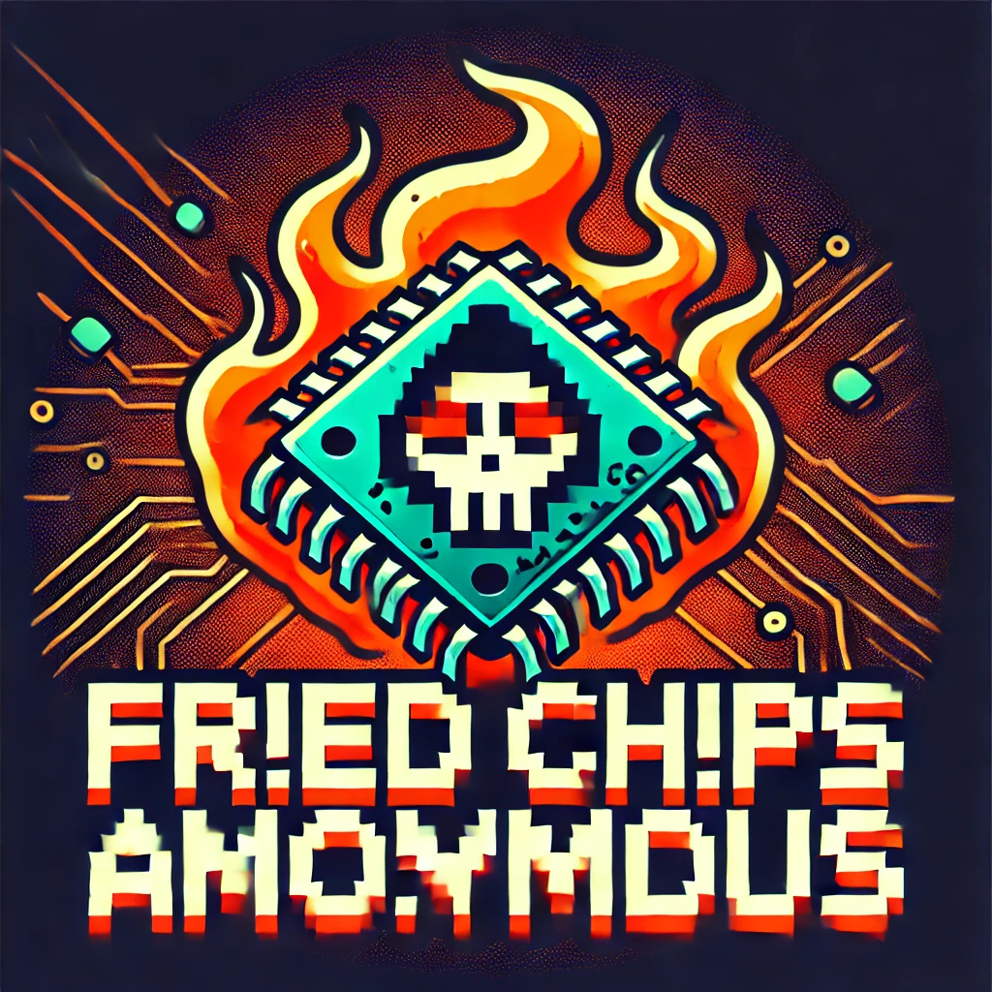

# Team: Burnt Fingers Club

**Michael Dumortier, Michael Branders, Onur & Yannick**

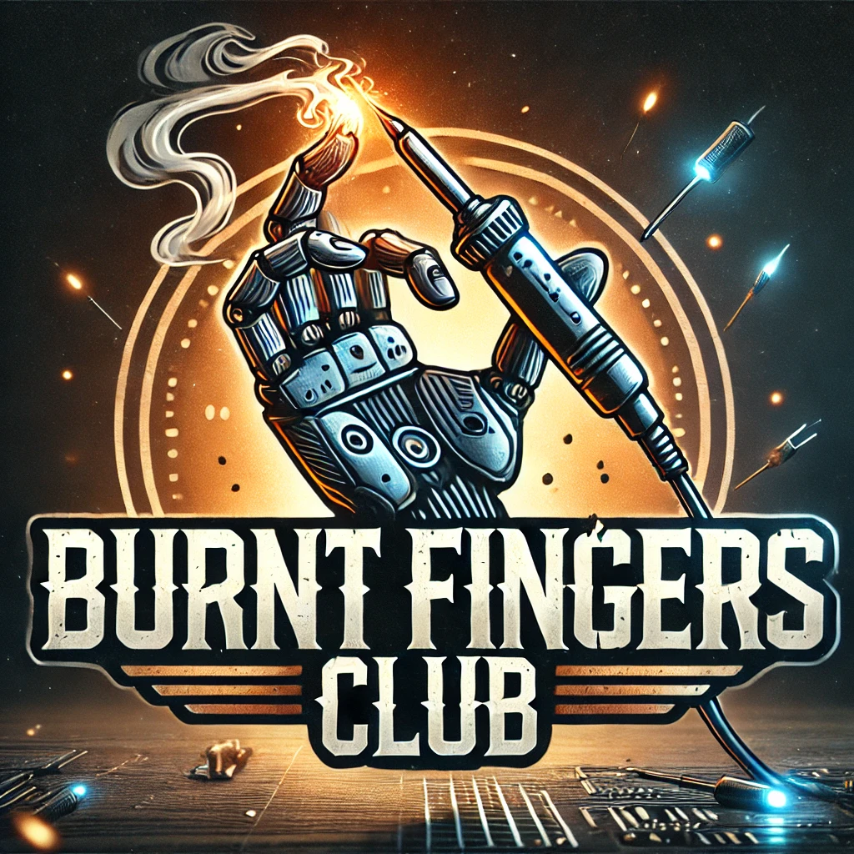

# Team: Sparks but No Ragrets

**Tom Marroyen, Jelle, Nicolas, Pierre & Tim**

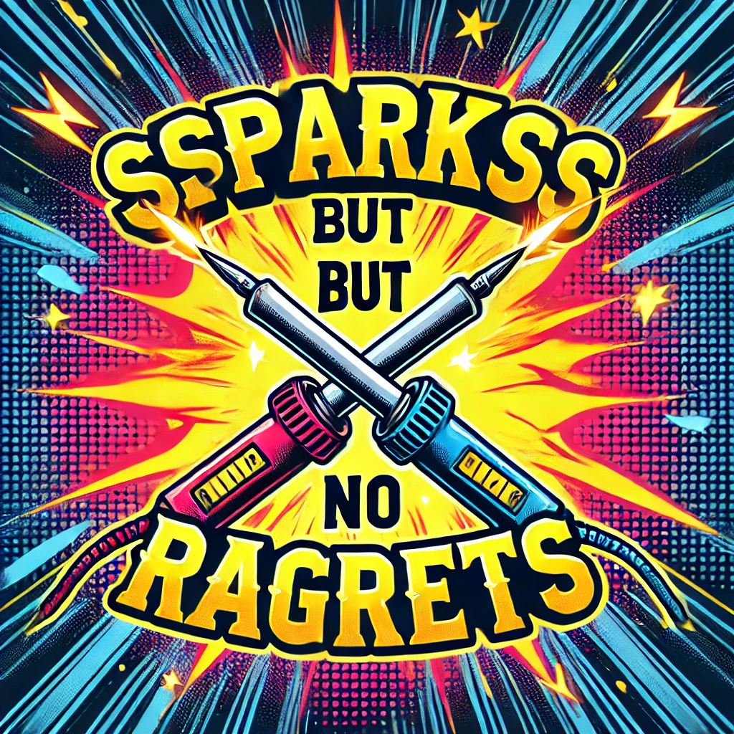

# Team: The Sparkonauts

**Thomas Janssens, Heleen, Nina, Tom Vanacker, Thomas De Brauwer**

